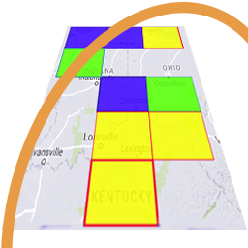
GridTracker ​v1.21.0613
An Amateur Radio Companion

June 13th, 2021

General Information

This is a hotfix release to fix an issue that when launching several logging utilities such as GridTracker and other logging programs that may all try to sync their LoTW logs at the same time and cause a trigger of LoTW’s log download abuse mechanism. Downloading of LoTW logs at start-up has been temporarily disabled while a more permanent solution is being worked on.

We want to thank everyone that contributes to GridTracker. Starting now if you donate to GridTracker and provide your call sign we’ll add you to the list in the next version. Then when your call sign will receive a special recognition icon next to it when is displayed within the program. If you’ve contributed to us in the past and want to be included, send an email with your call sign to ‘contact@gridtracker.org’.

Program Update
[Bug Fixes]
- Fix pulling down LoTW log at start-up causing issue for other programs that are trying to sync LoTW logs.
[Enhancements]
- Updated list of contributors.

GridTracker is:
Copyright © 1998-2020 by Stephen ‘Tag’ Loomis
Copyright © 2020-2021 by GridTracker.org
All rights reserved.

GridTracker uses the OSS compliant BSD 3 Clause License
Source code is available at GitLab: https://gitlab.com/gridtracker.org/gridtracker

