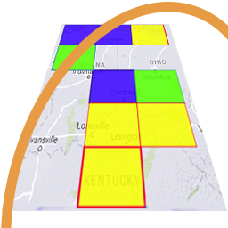
GridTracker v1.21.0928
An Amateur Radio Companion

Sept 28th, 2021

General Information

This is our September General Release after going a couple months without one. Our developers have been working on a handful of items to fix and update a few things in GridTracker in between cross country road-trips and all the stuff that is typical of late summer in North America. We also want to thank everyone that reports bugs and helps tests the fixes before we release them to the broader user base. If your interested in helping be a beta tester, join our Discord server and let us know.

Our biggest announcement in this release is that we have a new User Guide. Sarah N6OPE poked every button and control in GridTracker and wrote down what it did so you won’t have to. With help from some other members of our “Documentation Doctors” team, we’re adding new Frequently Asked Questions (FAQ) and How-To’s for linking GridTracker with all the other popular ham radio applications out there. You can find the new User’s Guide at https://gitlab.com/gridtracker.org/gridtracker/-/wikis/Home.

This release also now has a 64bit ARM (for Raspberry PI 4 and 64 bit Odroids) package and the ARM packages are using the latest NWJS for that platform. We thank Leonard László, the maintainer of the ARM NWJS packages for his work making that available!

We were informed and have made a fix for with ADIF records that contain non-latin characters that are often found in non-English names. Those were causing a miscount of the number of “characters” in the ADIF record sent out to other logging programs and services and causing those programs to fail to ingest the record properly.

Program Update
[Bug Fixes]
- Treat ADIF record values as byte length vs string length (to better handle UTF-8 data).
- Remove looking at fetched records for last date for LoTW fetches and use only headers (More reliable LoTW fetches).
[Enhancements]
- ARM builds now with NWJS 0.54.2 and 64 bit ARM binaries.

GridTracker is:
Copyright © 1998-2020 by Stephen ‘Tag’ Loomis
Copyright © 2020-2021 by GridTracker.org
All rights reserved.

GridTracker uses the OSS compliant BSD 3 Clause License
Source code is available at GitLab: https://gitlab.com/gridtracker.org/gridtracker

